MySQL - sales (via invoiceline) by genre name

SQL Server -  top 20 by customer (lastname & first name) sales (via invoiceline)

PostgreSQL - top 10  album (title) sales (via invoiceline)

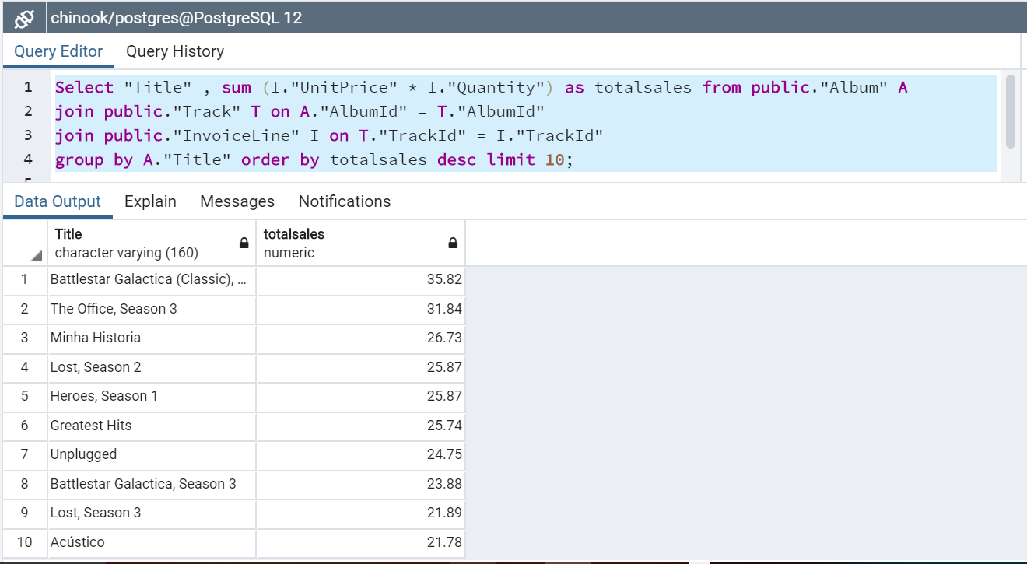

Oracle - sales total by Billing Country

